Prepared by: Naz barzan sleman

Subject: Programming Fundamentals

Supervised by: Shakhawan hussien

/\*

Q1). Write a C++ program, using Switch Statement, that reads two integer numbers and one character. The characters entered should include any of \*, /, + and -. When the user enters \*,

the program should multiply the two integers and print the result. When you enter /, the program should divide first number by the 2nd number and print the result … etc. Otherwise the program should print "Error! The operator is not correct.".

\*/

Solution:

#include <iostream>

using namespace std;

int main( )

{

int x,y;

float z;

char n;

cout<<"enter two integer numbers: ";

cin>>x>>y;

cout<<"enter one of this operator (\*,/,+,-): ";

cin>>n;

cout<<endl;

switch(n)

{

case '+': z=x+y;

cout<<"sum="<<z<<endl;

break;

case '\*': z=x\*y;

cout<<"mul="<<z<<endl;

break;

case '/':

if(y==0)

{

cout<<"error! Cannot divide by zero"<<endl;

break;

}

z=float(x)/y;

cout<<"div="<<z<<endl;

break;

case '-': z=x-y;

cout<<"sub="<<z<<endl;

break;

default: cout<<"error! the operator is not correct"<<endl;

}

return 0;

}

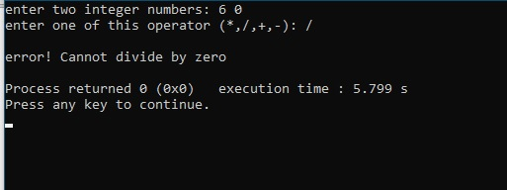Output:

/\*

Q2). Write a C++ program, that reads an integer number n. Then find the factorial of n (n!), and print it.

\*/

Solution:

#include <iostream>

using namespace std;

int main()

{

int f=1;

int n;

cout<<"Enter an integer number: ";

cin>>n;

for(int i=1;i<=n;i++)

f=f\*i;

cout<<"fact="<<f<<endl;

return 0;

}

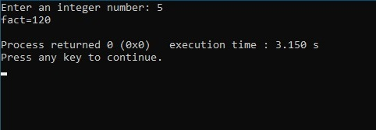Output:

/\*

Q3). Write a C++ program that reads the names of 10 students with their marks using two vectors

whose names are Names and Marks respectively, then find and print number of passed and failed

students with a list of names for each of passed students and failed students.

\*/

Solution:

#include <iostream>

#include <cstring>

using namespace std;

int const n=10;

int main()

{

string nam[n],namp[n],namf[n];

int mark[n],cp=0,cf=0;

cout<<"Enter Names and Marks of 10 Students respectively"<<endl;

for(int i=0;i<n;i++)

cin>>nam[i]>>mark[i];

cout<<endl;

for(int i=0;i<n;i++)

{

if(mark[i]>=50)

{

namp[cp]=nam[i];

cp++;

}

else

{

namf[cf]=nam[i];

cf++;

}

}

cout<<"Number of passed students="<<cp<<endl;

for(int i=0;i<cp;i++)

cout<<namp[i]<<endl;

cout<<endl;

cout<<"Number of failed students="<<cf<<endl;

for(int i=0;i<cf;i++)

cout<<namf[i]<<endl;

cout<<endl;

return 0;

}

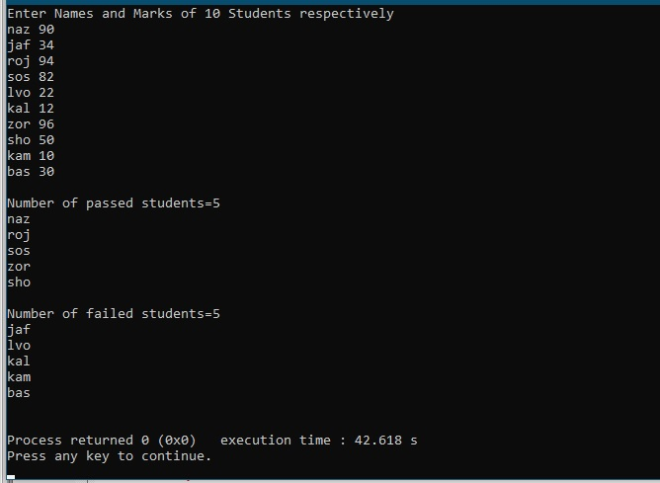Output:

/\*

Q4). Write a C++ program that requests numbers consecutively from the user within a range. The program should stop when the number is out of range, using while loop.

\*/

Solution:

#include <iostream>

using namespace std;

int main()

{

float a,b,num;

cout<<"Enter your Range [a,b]: ";

cin>>a>>b;

cout<<endl;

cout<<"the range is: ["<<a<<","<<b<<"]"<<endl;

cout<<"Input a number"<<endl;

cin>>num;

while(num>=a && num<=b)

{

cout<<"Input a number"<<endl;

cin>>num;

}

cout<<"The number out of range"<<endl;

return 0;

}

Output:

